University of Washington, Tacoma  TCSS 342, Winter 2005 (Stepp)  Homework Assignment 04: Sort Detective | Assigned: Thursday, February 10, 2005  Due: Thursday, February 17, 2005, 4:15pm (in class)

This written assignment focuses on sorting. This is an individual assignment, to be turned in on paper in class.

Background Information:
This assignment asks you to evaluate anonymous sorting algorithms, based only on their external behavior, to figure out which is which. The algorithms are the following:

- Bogo sort
- Bubble sort
- Selection sort
- Insertion sort
- Merge sort
- Quick sort (using the first element in the range as the pivot for partitioning)
- Shell sort (another sorting algorithm that we have not seen in detail)
    - see textbook pp. 289-293; performance is similar to merge sort, but better on ascending/descending input than merge sort)

You will be provided with a testing applet that you can run in your web browser. The applet will let you run any of the algorithms. It doesn't tell you which is which; it only refers to them by a number. Your goal is to run the applet several times with different parameters, observe the behavior of the sorting algorithms, and discover which is which.

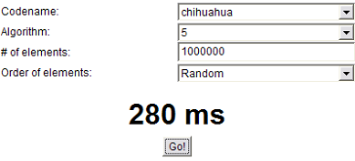
When you run the applet, you will see a user interface asking for several pieces of information. You may enter the following information into the applet:

- Codename: This is your code name as given to you by Marty in class; the same one used to email scores. (You must select your code name before running any of the sorts.)
- Algorithm: You can choose any of the anonymous sorting algorithms to run.
- # of elements: Type in how many elements should be in the array to sort. (You must type a non-negative number in this box before running any of the sorts.)
- Order of elements: Since some sorting algorithms perform differently when given different input, you can choose to have your input array in the following orders:
  - Random: elements are given initial values randomly.
  - Ascending: elements' values go from smallest to largest; so they are already in sorted order.
  - Descending: elements' values go from largest to smallest; so they are in backwards order.

What to turn in:
Turn in a written report explaining which sort is which, including supporting data to back up your claims. The following supporting data is required, for every sorting algorithm:

- A table and graph of the runtime of each algorithm, with the input in each order, for several (at least four) nontrivial input sizes. A nontrivial input size means one where the runtime is more than just a few milliseconds. To reduce margin of error, run the algorithm a few times on each input size and choose the median of the three times. You need not use the same input sizes for every algorithm, since this might not produce the most useful data; but if you intend to compare two algorithms directly by how fast they run, you should use the same input size for that comparison.
Each algorithm should have its own table and graph. Your graphs should show input size on the x-axis and runtime on the y-axis. You can draw the graphs by hand or on the computer. The three input orders (random, ascending, descending) can be on the same graph or on different graphs if you like. Here is an example:

 | Average runtime for three runs (ms)
Input size | Random | Ascending | Descending
10000 | 79 | 50 | 102
20000 | 219 | 102 | 398
30000 | 681 | 153 | 1443
40000 | 1842 | 198 | 5017
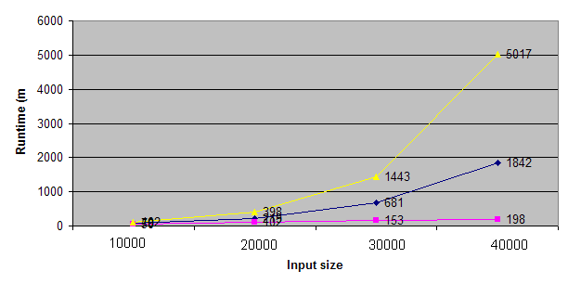

- Your estimation of the Big-Oh for each algorithm, based on the data you gathered.
- Your statement of which sorting algorithm it is, along with your reasoning. You should base your reasoning on the following:
  - growth rate (Big-Oh) of the algorithm's runtime as input size changes
  - speed of the algorithm compared to the other algorithms
  - changes in behavior of the algorithm, if any, for different input orderings

If all of your claims are based only on relative speeds of the algorithms ("Algorithm 5 was the fastest, so therefore it's X-Sort"), you will not receive full credit.

Submission:
Turn in your written report on the due date, in lecture, at the start of class. This program must be completed individually. It is subject to the plagiarism and conduct rules specified in the course syllabus. You may discuss general ideas for testing the sort algorithms, but you should not share sort data or answers with classmates. If you get help from friends, classmates, books or websites, please cite this in comments in your code.

